# Design plan

Bird movement

1. Bird moves up on the click of a mouse
2. Bird moves down when it is not clicked (potentially accelerates as it moves down)
3. Bird should move forward at constant speed or the pipes (background) move

Background

1. Generate random length of pipes OR random pipe gap and fill up the rest with the pipe
2. Pipe width – fixed
3. Background image – fixed

Game mechanics

1. 3 hp in total
2. When the bird hits the pipe, minus 1 hp and respawn
3. When the bird hits the ground, minus 1 hp and respawn
4. No more hp means game ends and menu comes up
5. When the bird respawns, it starts with nothing around it, but the score continues
6. When it respawns or when the game starts, it will start flying instantly (no countdown)
7. If we collect the coins, it will give 5 points
8. If the bird successfully passes through the gap, it will give 1 point
9. Show the time of survival

Menu/functions

1. Start – button0
2. Reset button – button 1
3. Exit – button2
4. Mode (chosen with DIP switch0)
   1. Practice tool – ‘1’
   2. Single player – ‘0’
5. Pause button – switch8

Other factors

1. Presents/buffs
   1. Invincible for 5 secs
   2. Give 50 points

# Block Diagram

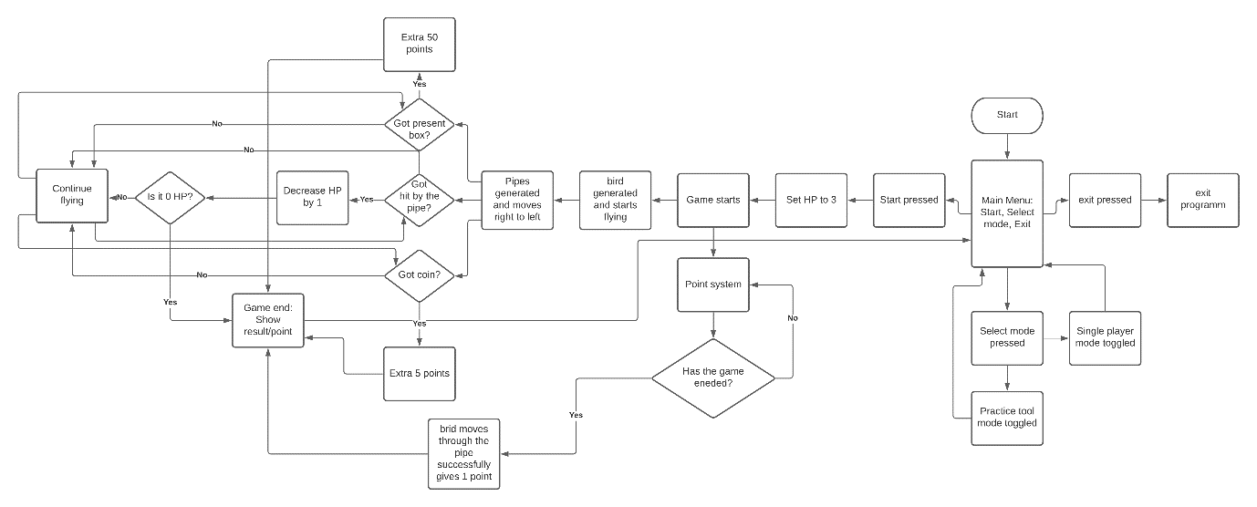

# High level start machine

